ITC 215 – Introduction to Programming with Java
Assignment 2: Loops and Nested Loops
Instructor: Dr. Sami Naji
Name: Sewita Ahmadi
Due date: October 12,2026

Task 1.1
int total = 0;
for (int i = 1; i <= 4; i++) {
total = total + i * 2;
System.out.println("i = " + i + ", total = " + total);
}

Trace Table
Pass | i | Total(after) | Printed line
1 | 1 | 2 | i = 1 , total = 2
2 | 2 | 6 | i = 2 , total = 6
3 | 3 | 12 | i = 3 , total = 12
4 | 4 | 20 | i = 4 , total = 20

Exact output
i = 1, total = 2
i = 2, total = 6
i = 3, total = 12
i = 4, total = 20

Guiding Questions
1. What is the value of total before the loop starts?
total = 0.
2. How many times does the loop body run? How do you know?
Four times, because i takes the values 1, 2, 3, and 4, and the condition is i <= 4.
3. After the last pass, i becomes 5. Why does the loop stop?
The condition i <= 4 becomes false when i = 5.
4. Now run the code. Does your trace table match the real output?
Yes, the trace table matches the output shown above.

Task2.2
int n = 20;
int steps = 0;
while (n > 3) {
n = n - 6;
steps++;
}
System.out.println("n = " + n + ", steps = " + steps);

Trace Table
Pass | n (after) | steps (after)
1 | 14 | 1
2 | 8 | 2
3 | 2 | 3

Exact output
n = 2, steps = 3

Guiding Questions
1. Write n and steps after each pass of the loop in a small table.
Pass 1: n = 14, steps = 1
Pass 2: n = 8, steps = 2
Pass 3: n = 2, steps = 3
2. At what value of n does the condition n > 3 become false?
It becomes false when n = 2.
3. What is the final line printed? Run the code to check.
n = 2, steps = 3
4. What would happen if you removed the line n = n - 6;? Explain in one sentence.
The loop would run forever because n would stay at 20, so n > 3 would always be true.

Task 4.1
for (int i = 1; i <= 3; i++) {
for (int j = 1; j <= 2; j++) {
System.out.println("i = " + i + ", j = " + j);
}
}

Exact output
i = 1, j = 1
i = 1, j = 2
i = 2, j = 1
i = 2, j = 2
i = 3, j = 1
i = 3, j = 2

Guiding Questions
1. For i = 1, what values does j take? What happens to j when i becomes 2?
When i = 1, j takes the values 1 and 2. When i becomes 2, the inner loop starts again, and j resets to 1.
2. Is there a relationship between the number of outer passes, inner passes, and total prints?
Yes. There are 3 outer passes and 2 prints per outer pass, so there are printed lines.
3. What would the total be if the loops were i <= 3 and j <= 4?
There would be printed lines.

Part 2: Basic Loops
Task 2.1 Output Screenshot
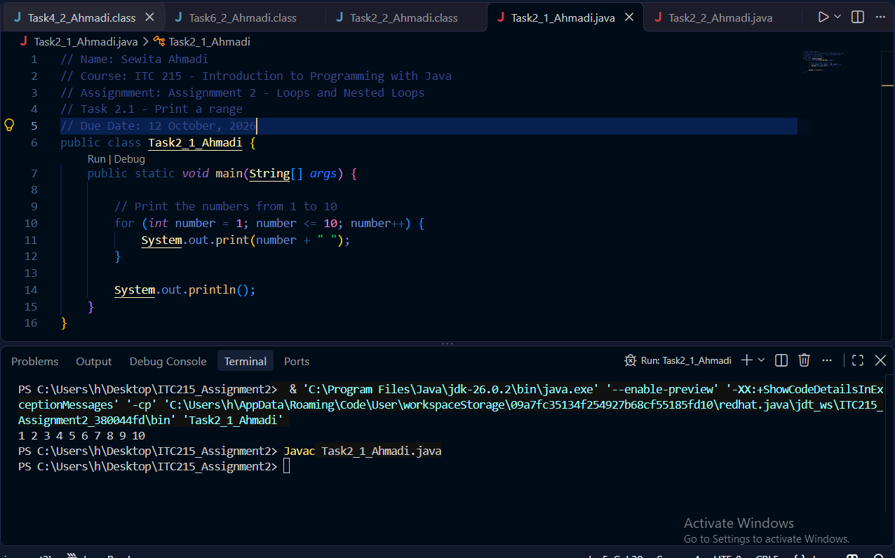

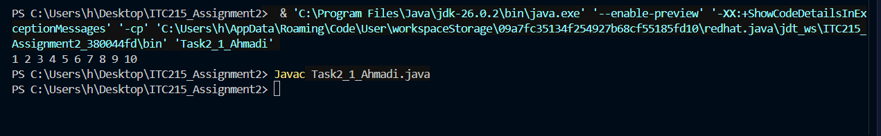

Task 2.2 Output Screenshots
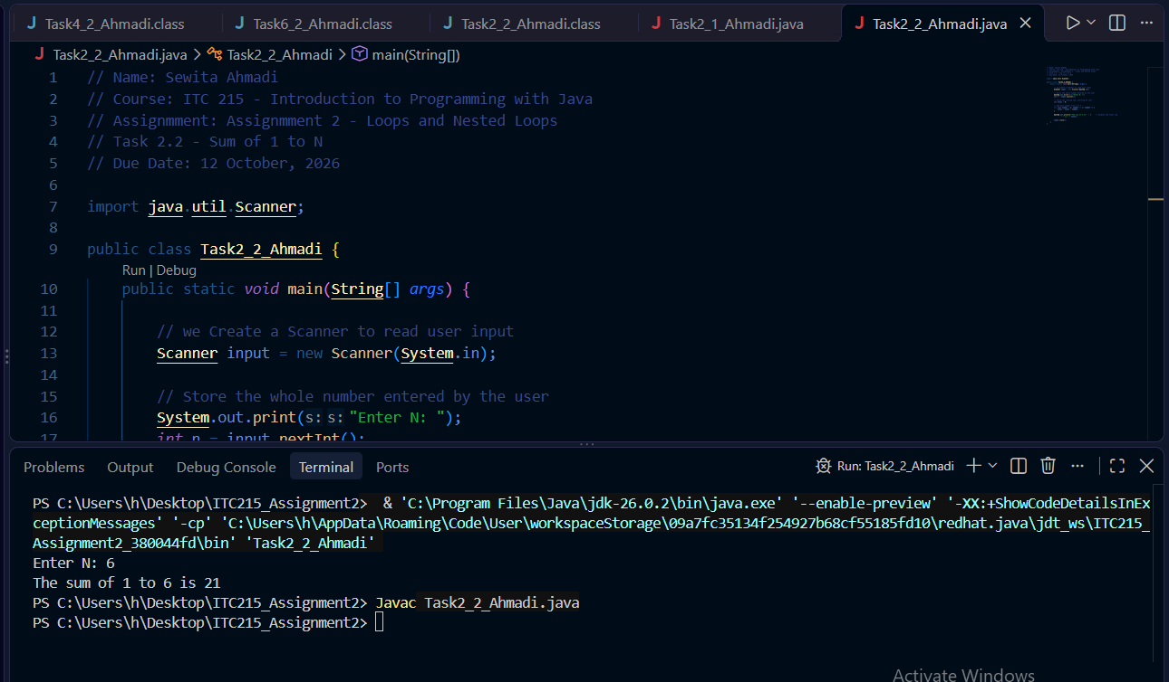
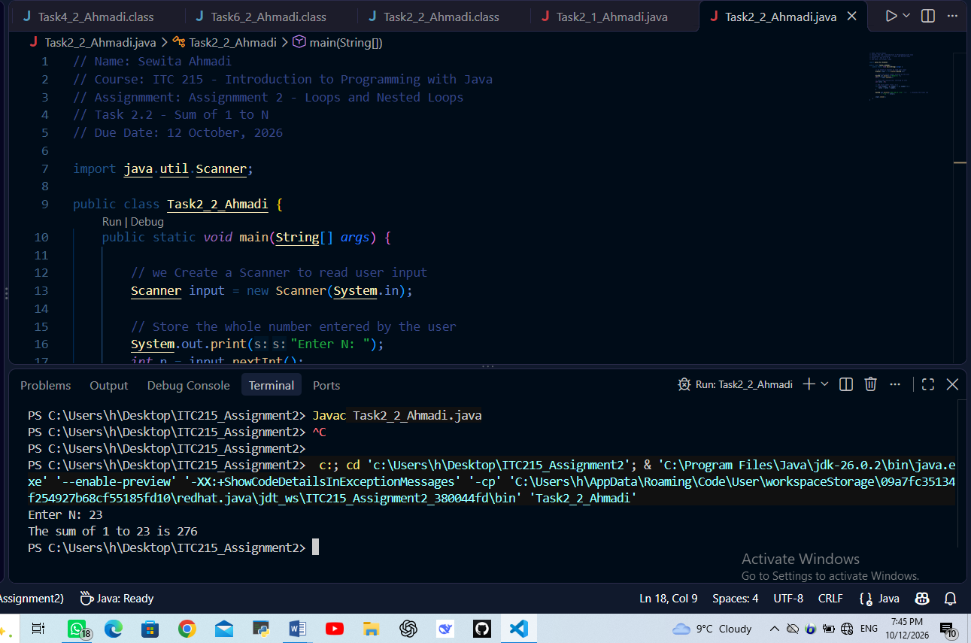
Task 2.3 Output Screenshot
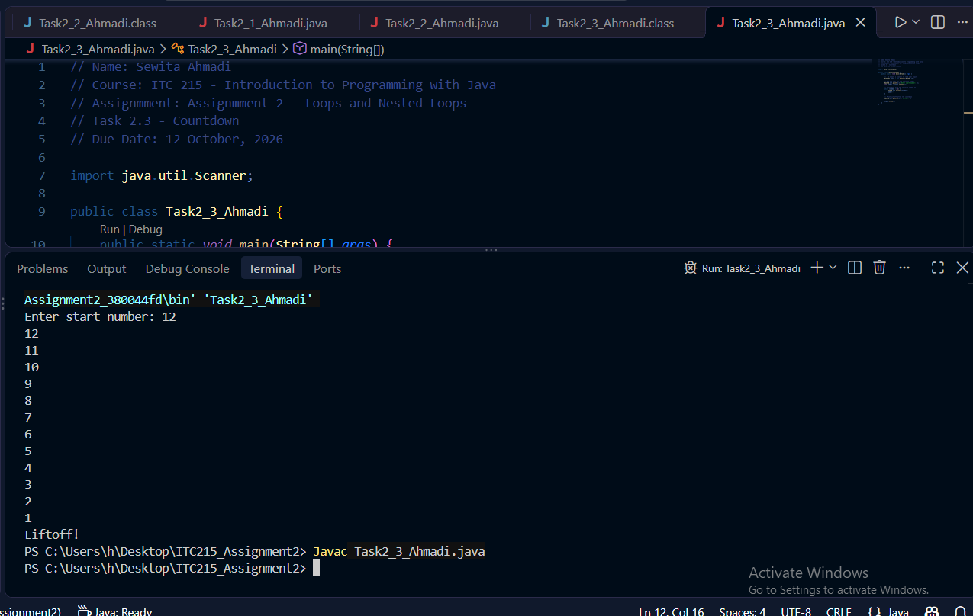
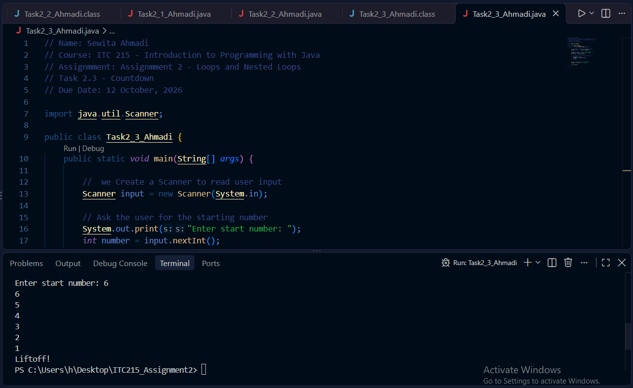
Task 2.4 Output screenshot
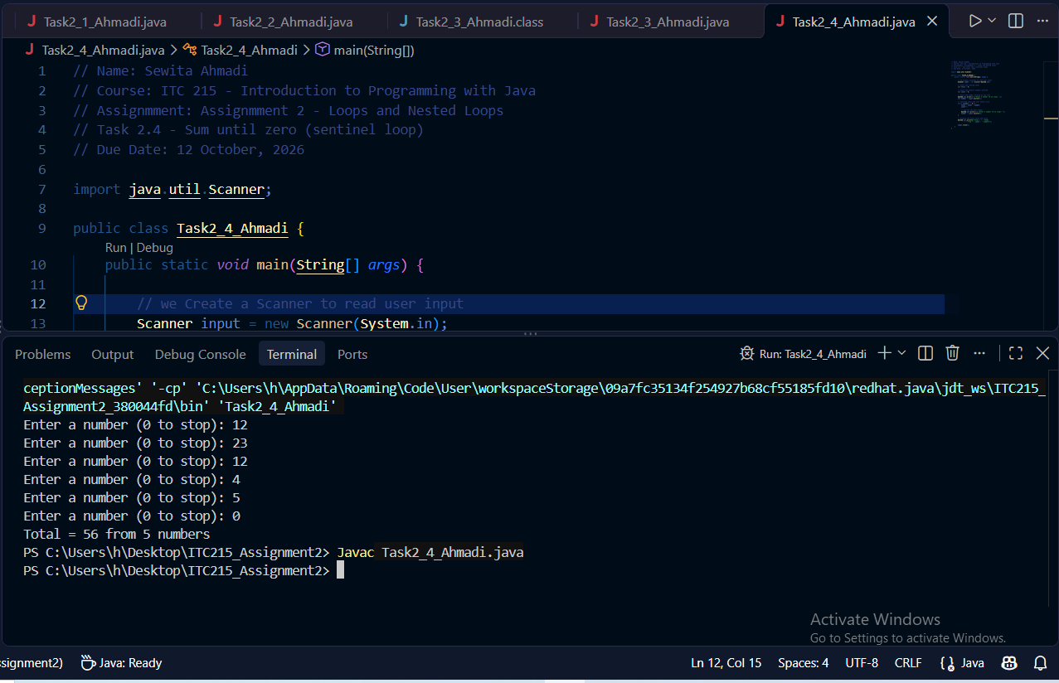
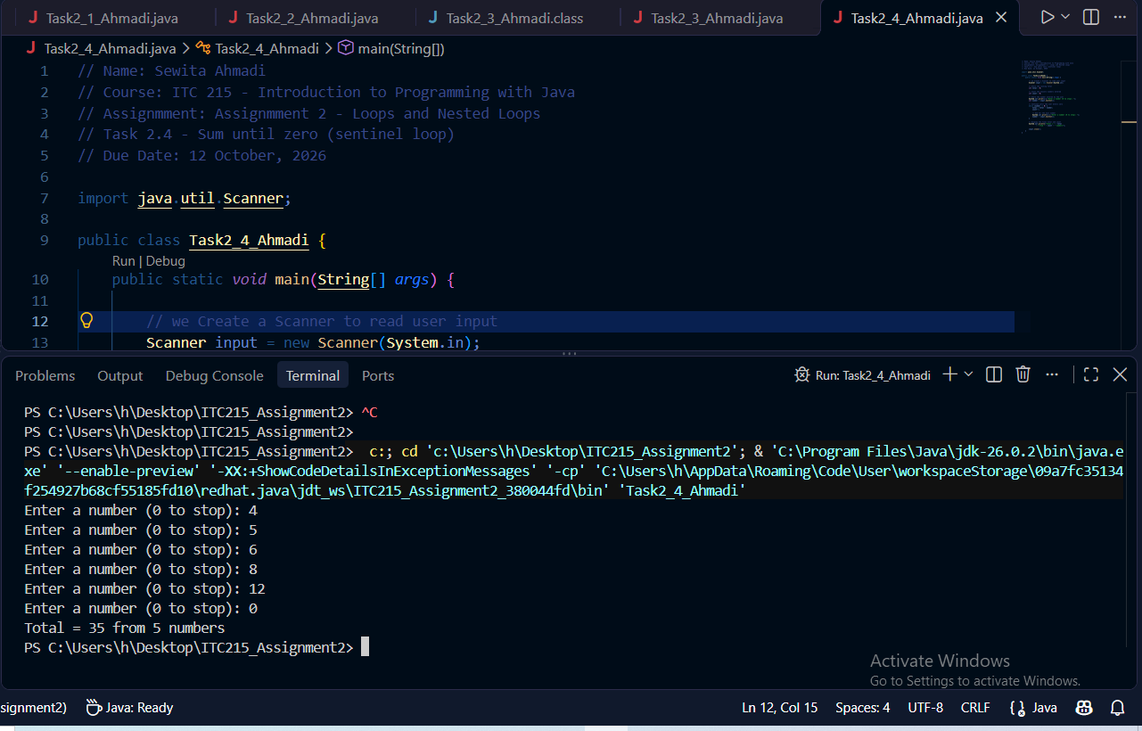
Task 2.5 Output Screenshots
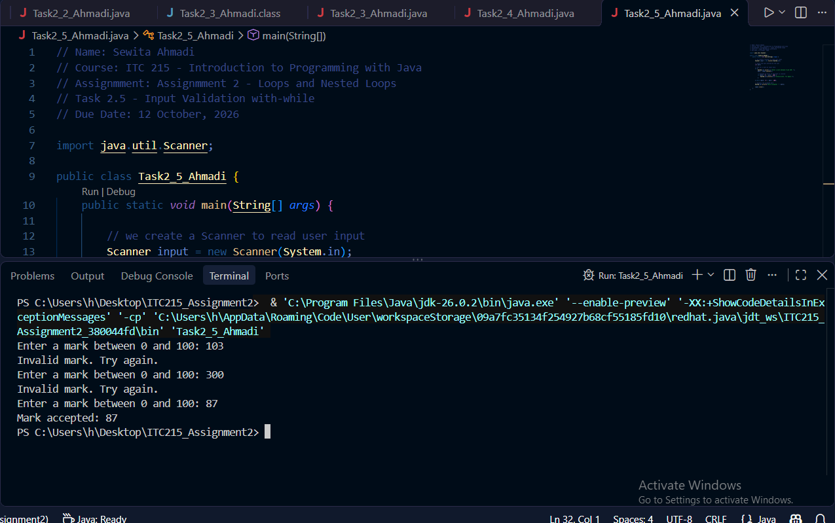
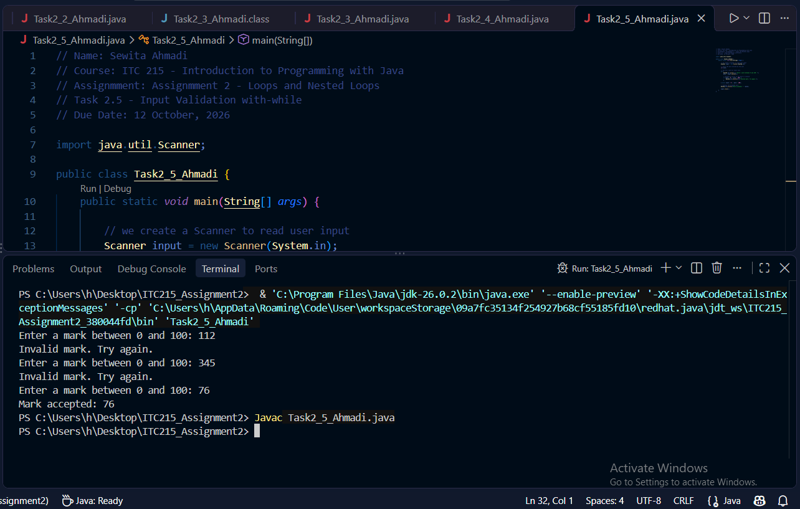

Part 3: Intermediate Loop Programs
Task 3.1 Output Screenshot
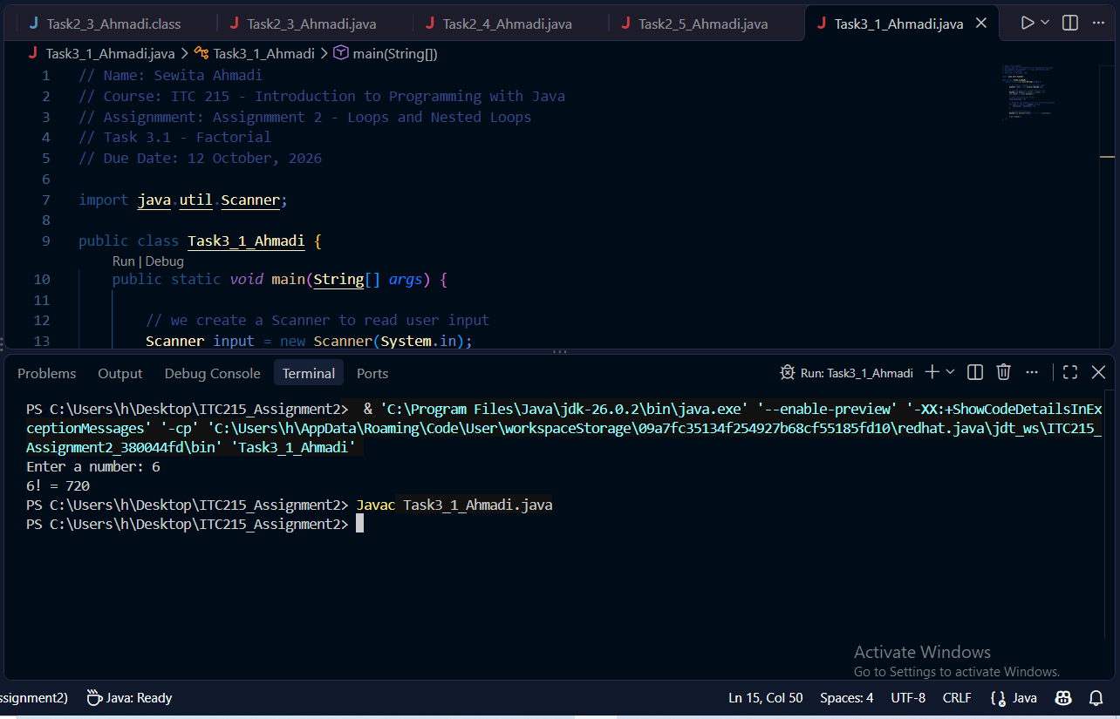

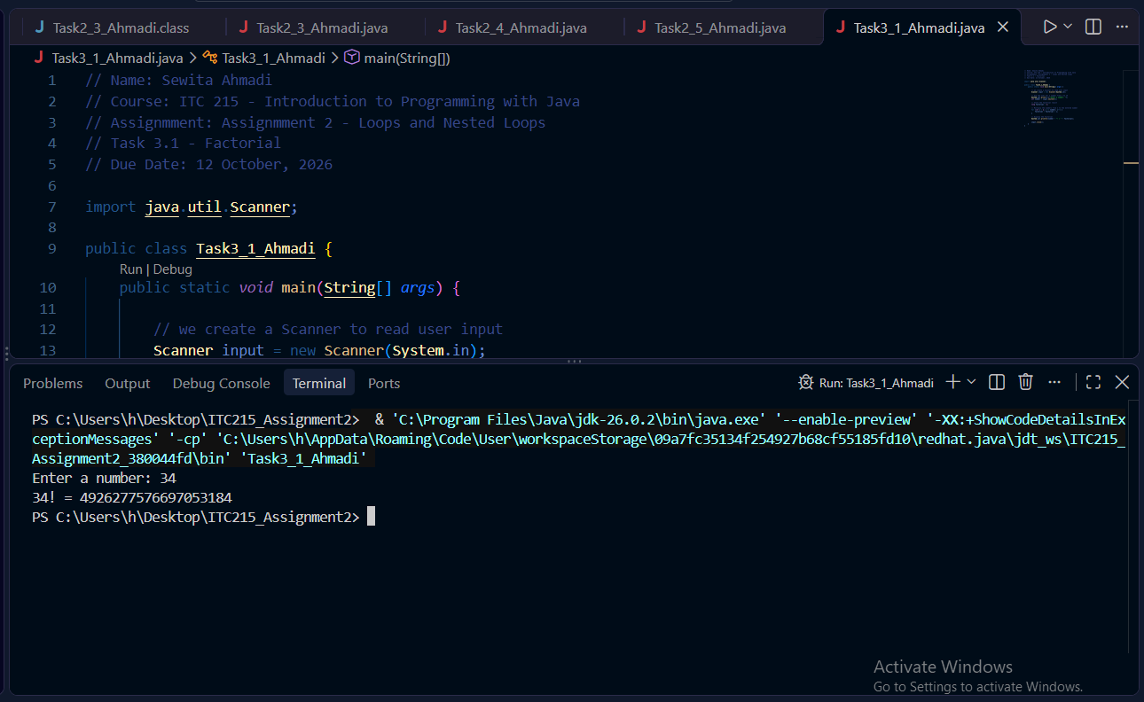
Task 3.2 Output Screenshots
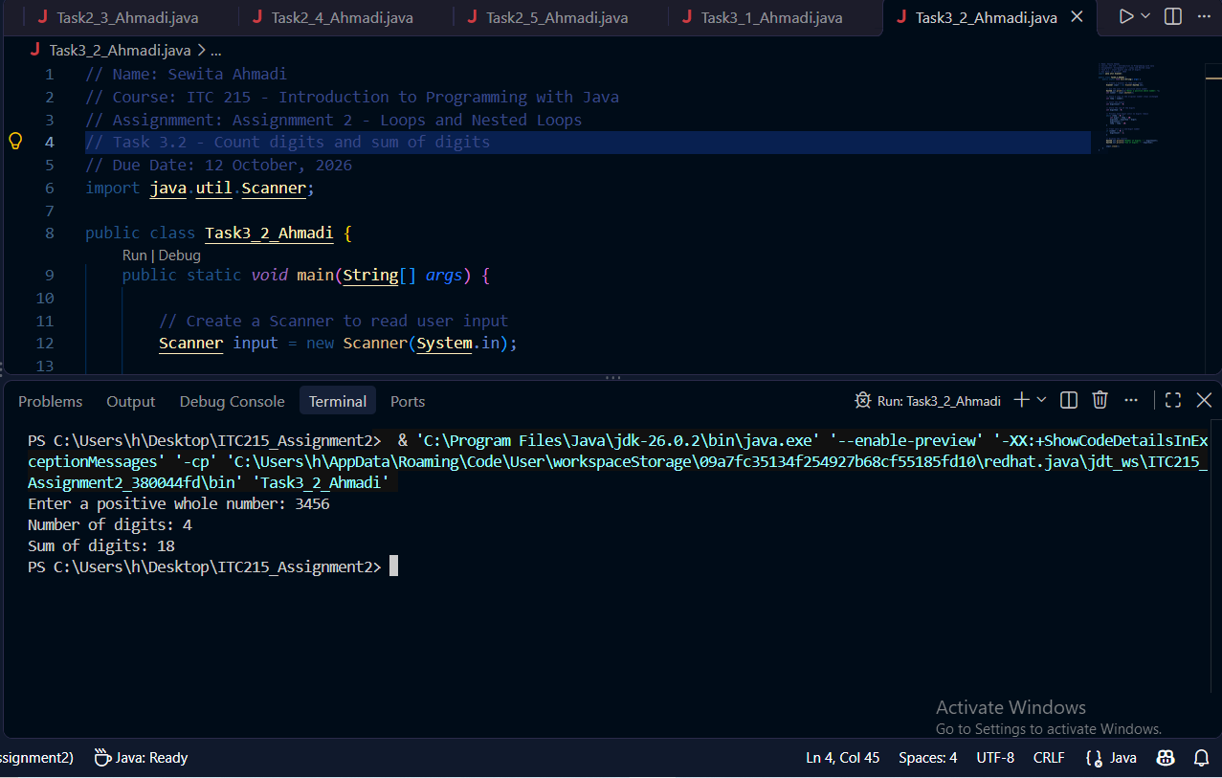

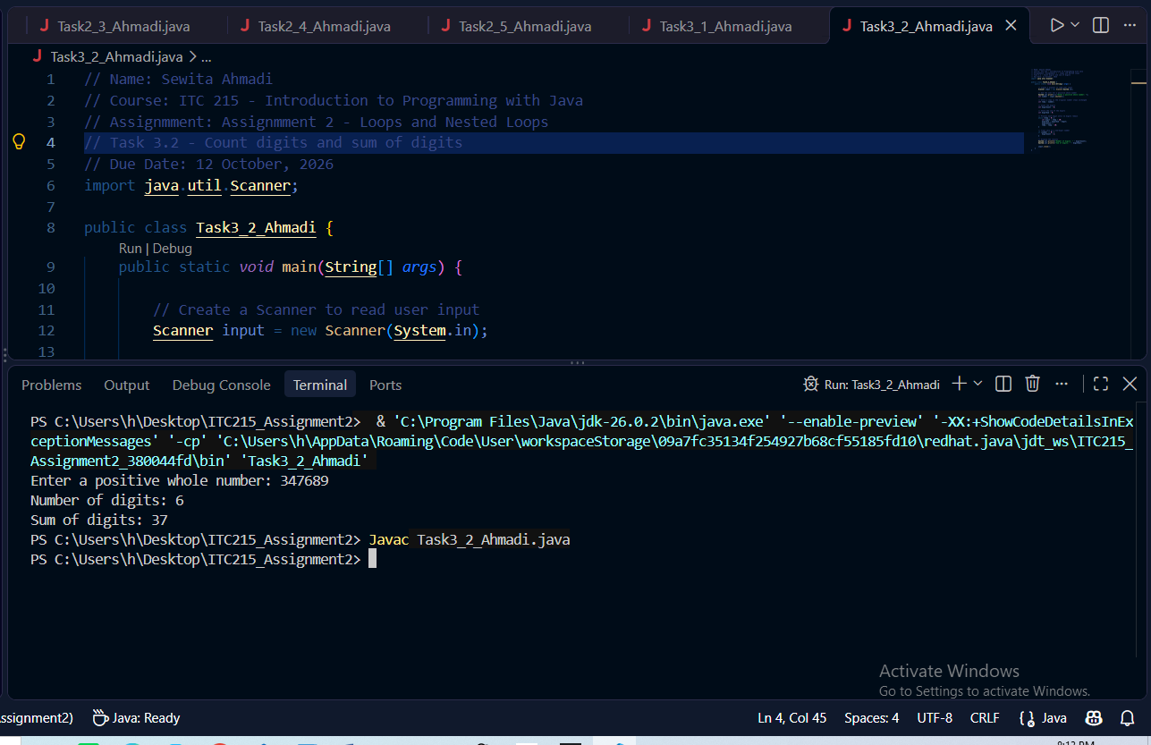
Task 3.3 Output screenshot
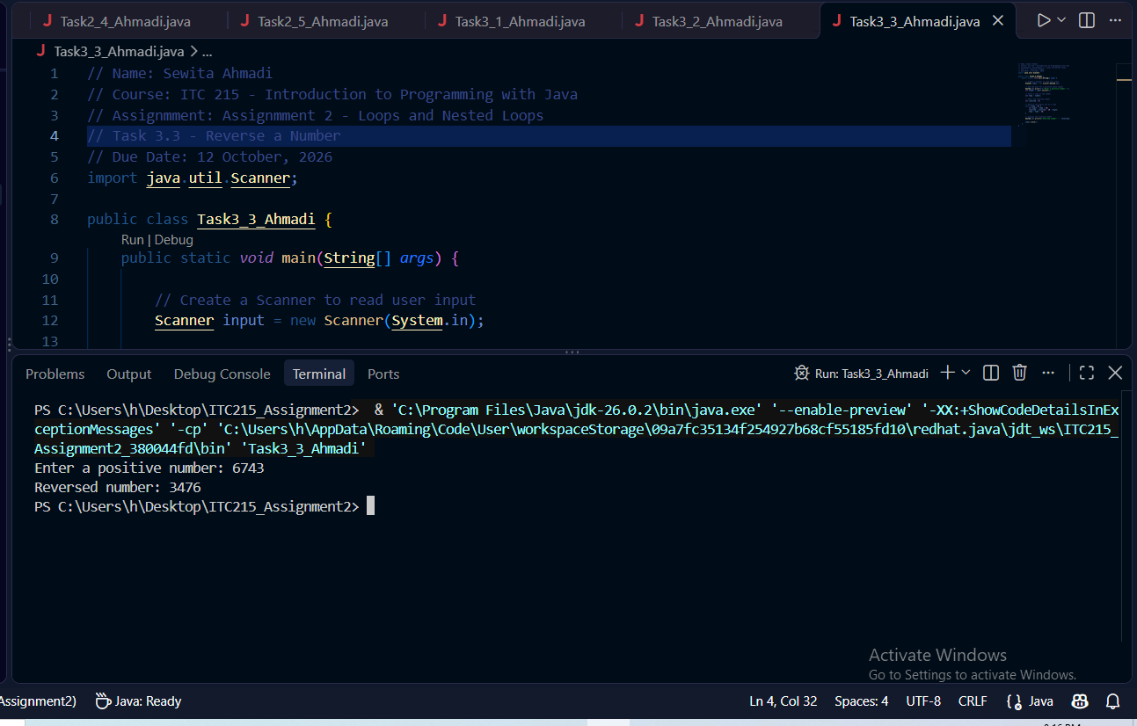
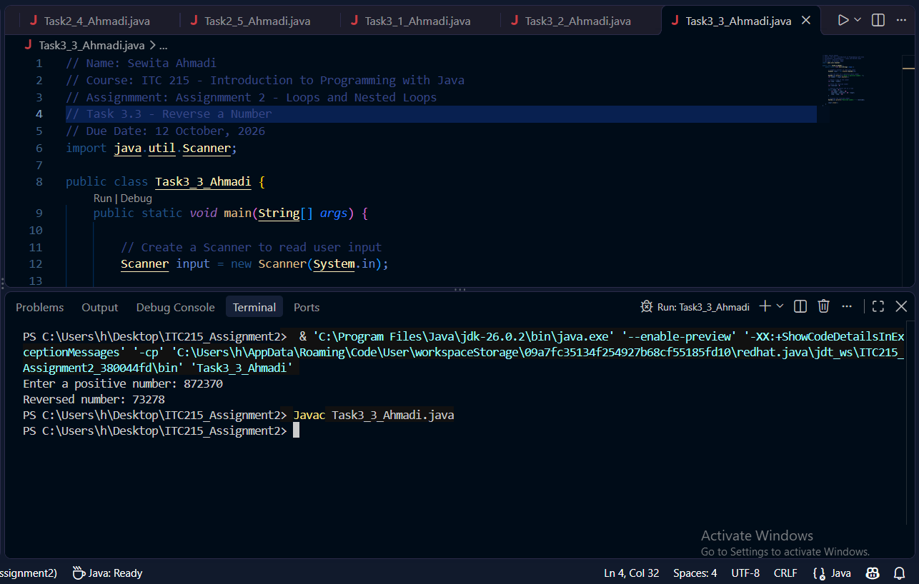

Task 3.4 Output Screenshot
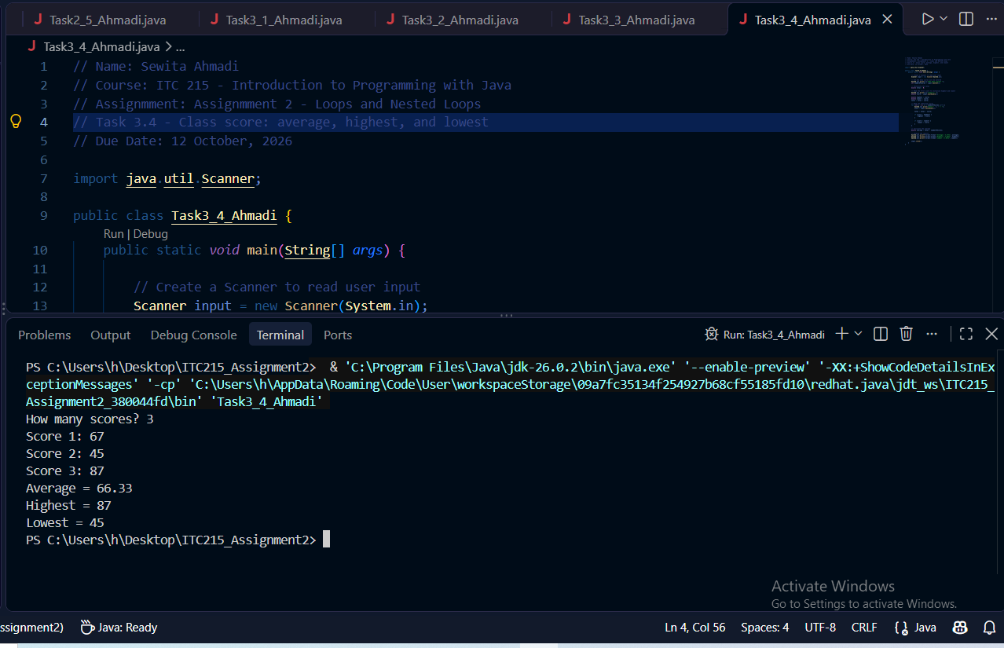
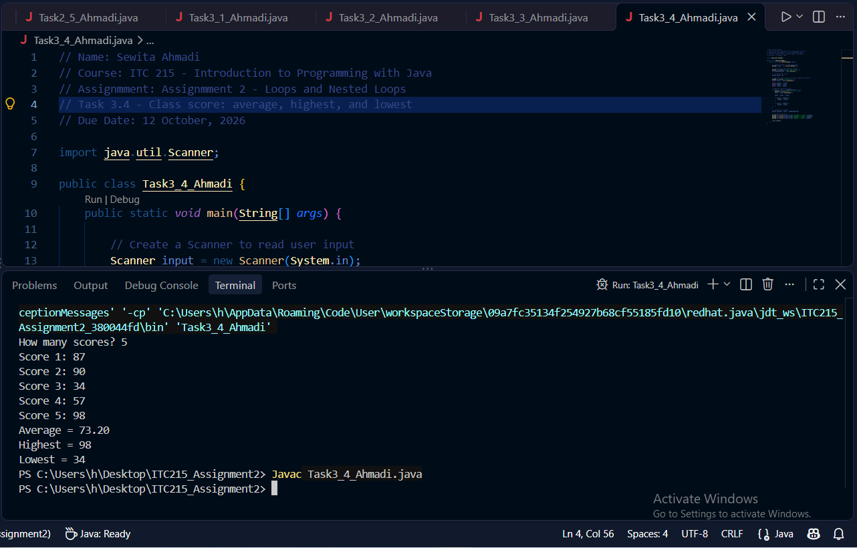

Part 4: Introduction to Nested Loops
Task 4.2 Output Screenshot
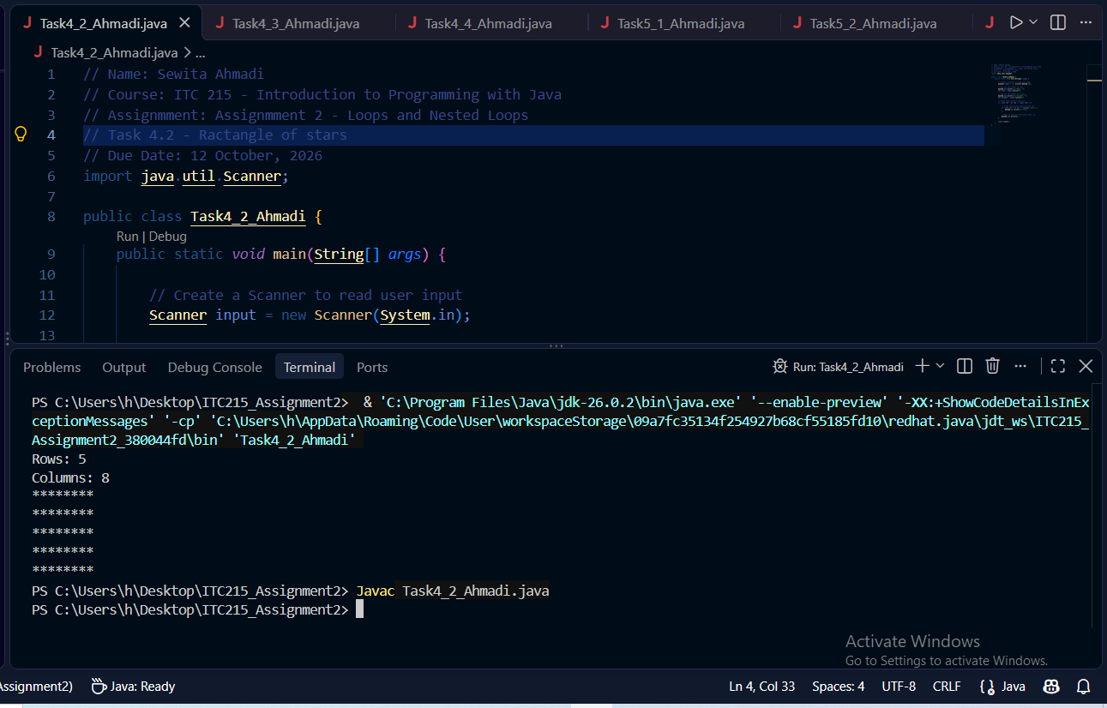
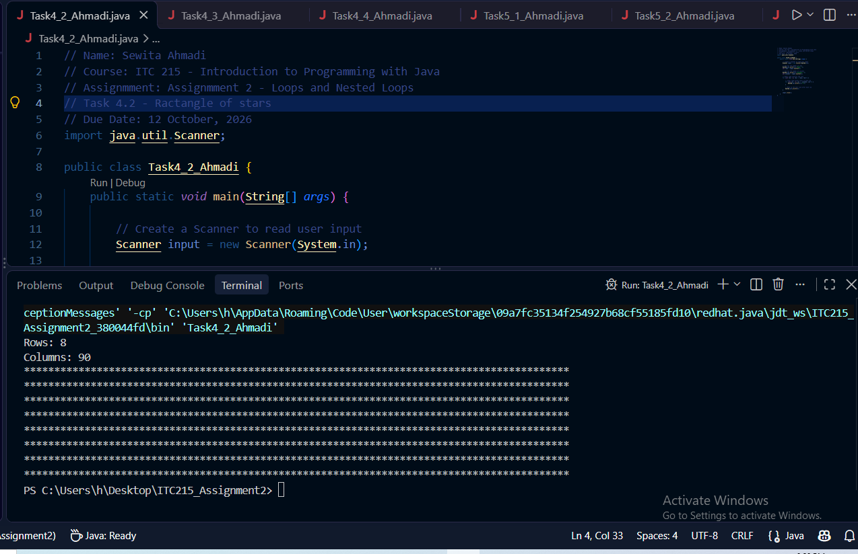
Task 4.3 Output Screenshot
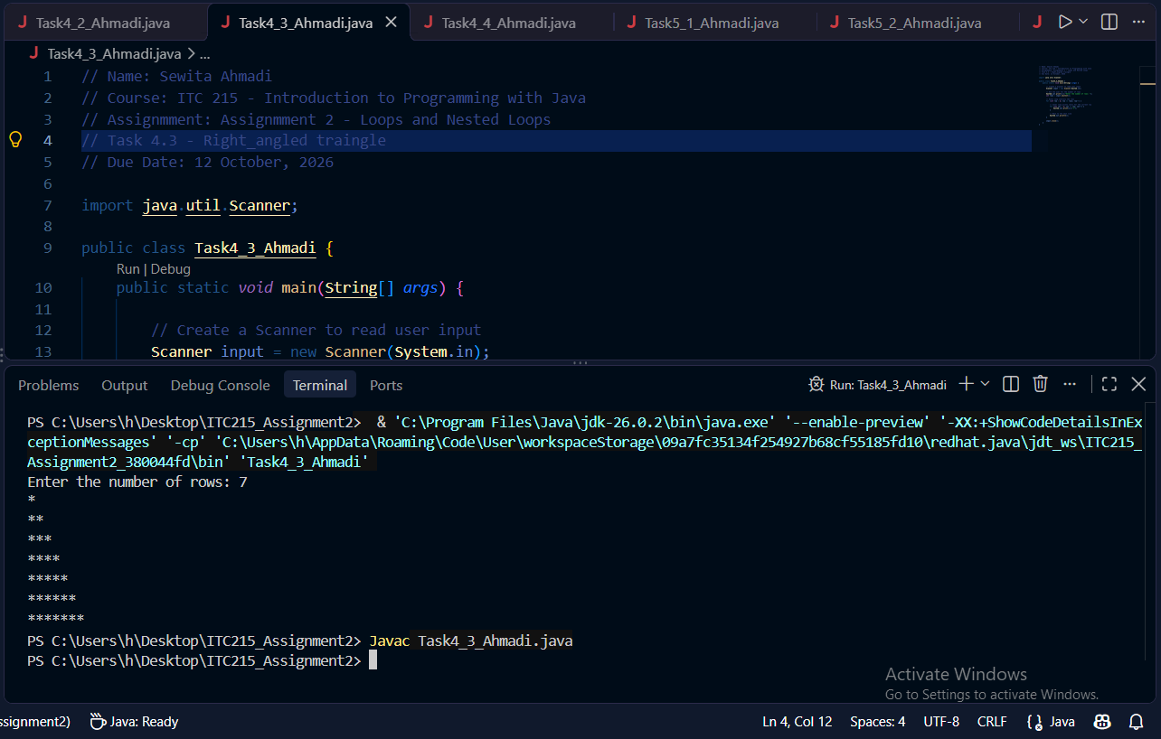
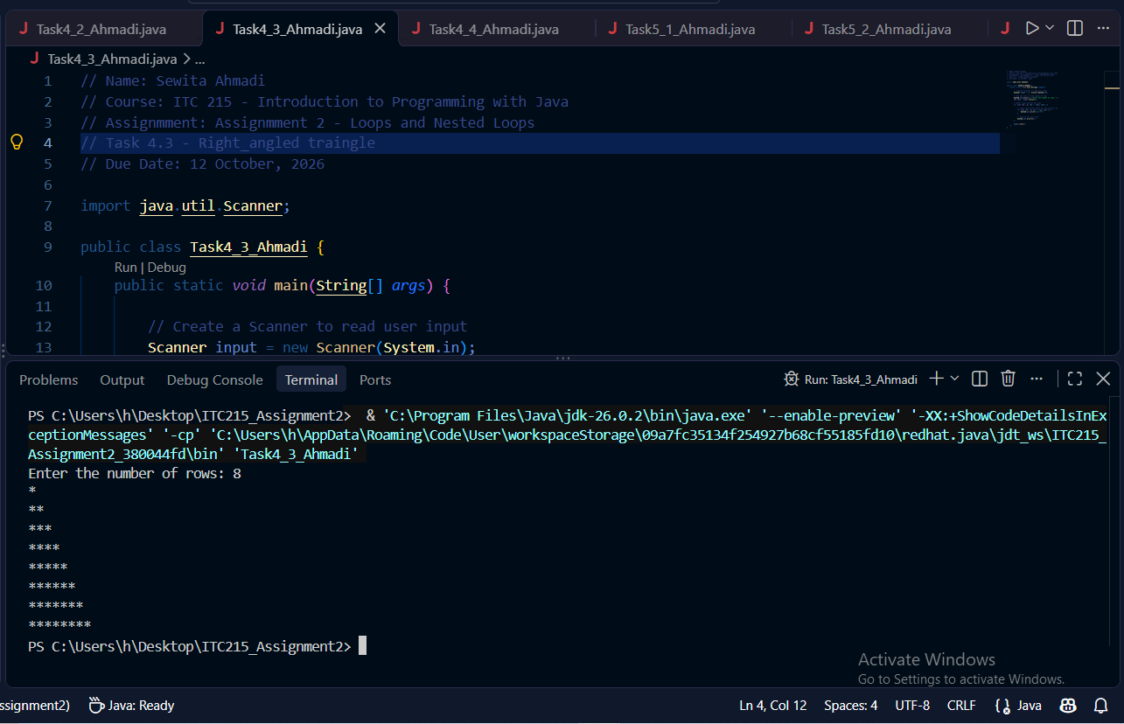

Part 5 - Advanced Nested Loops: Tables and patterns
Task 5.1 Output Screenshot
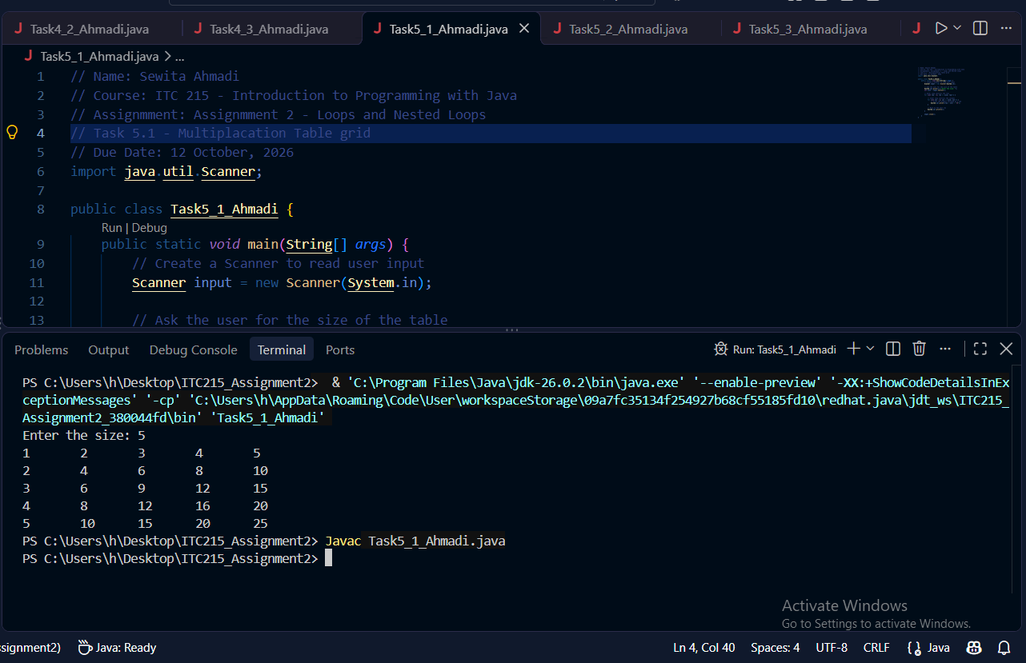
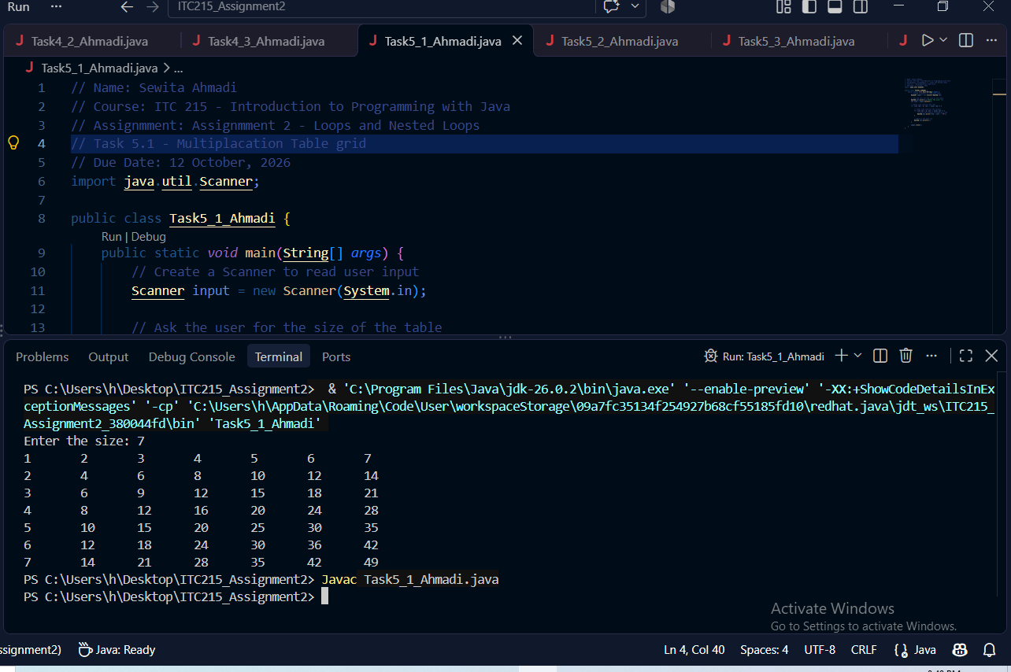

Task 5.2 Output
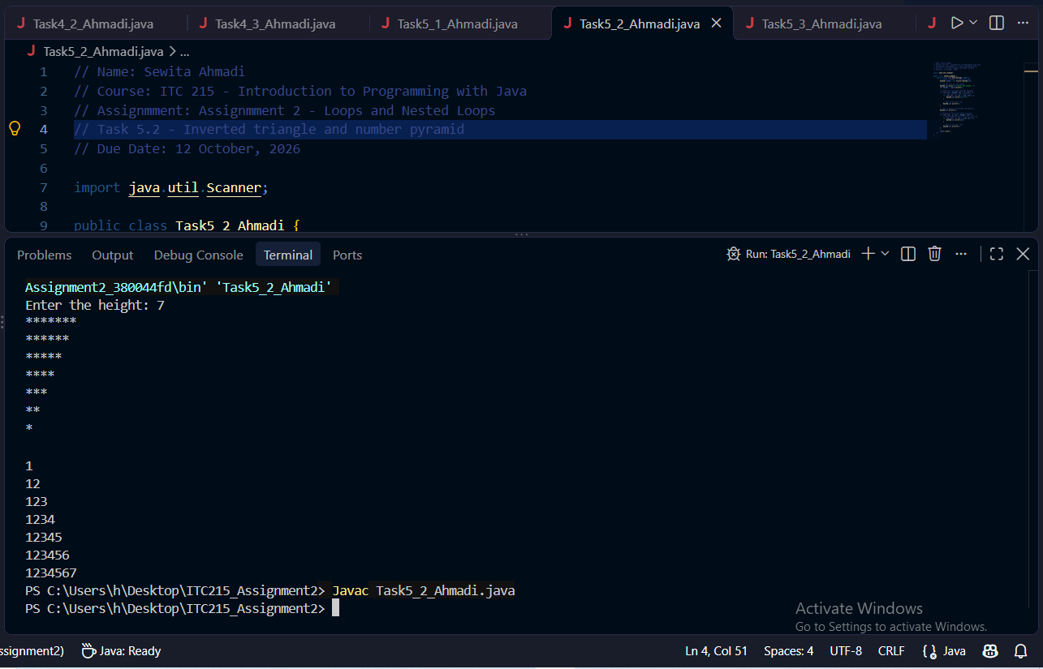
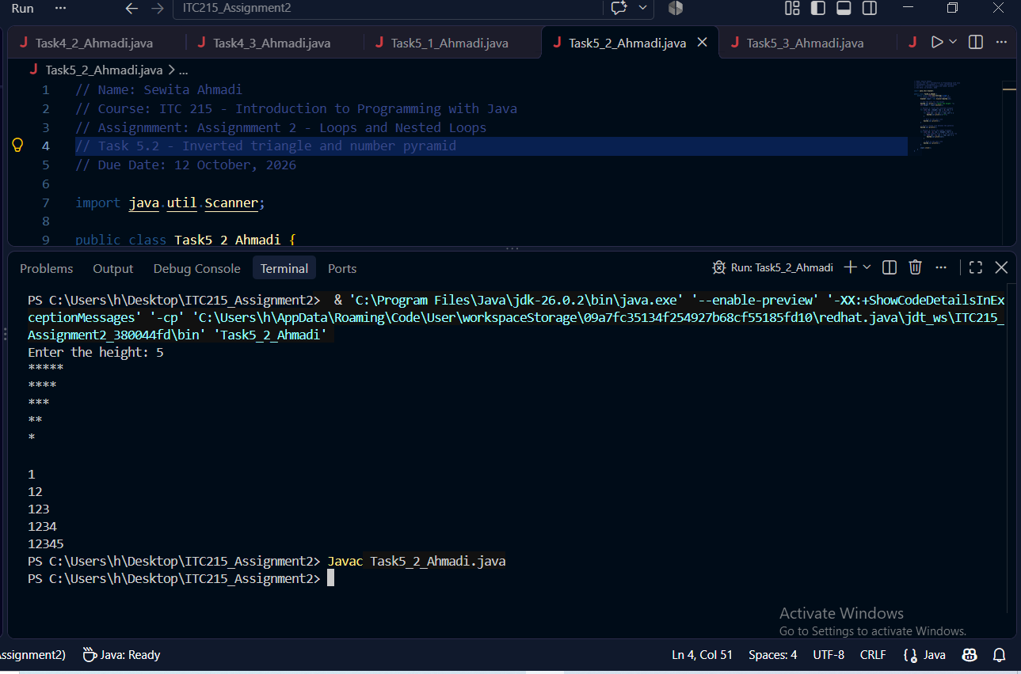

Task 5.3 Output screenshot
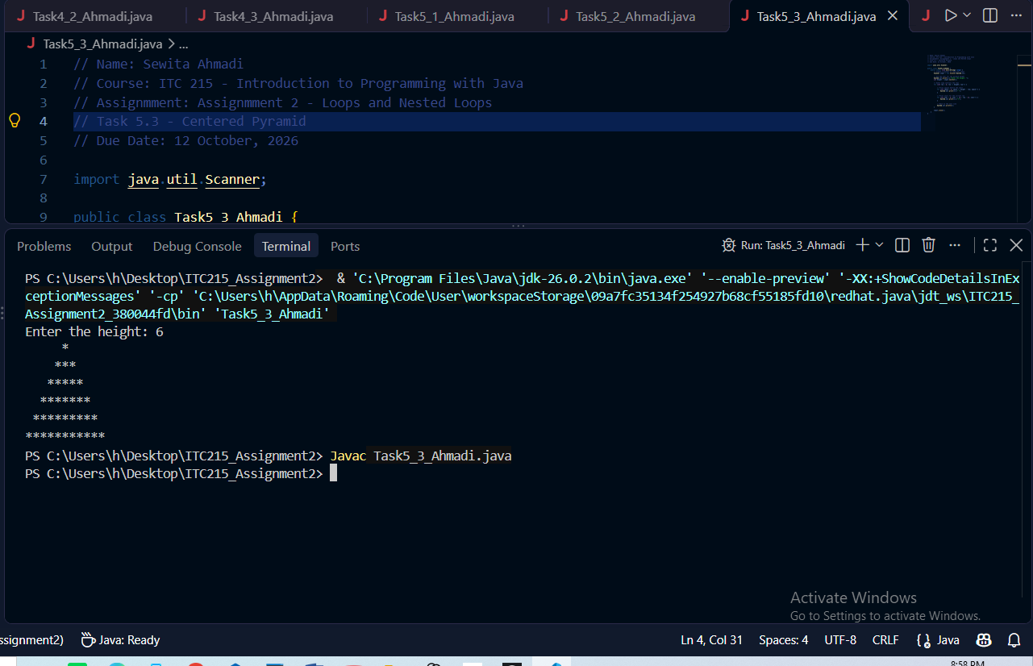
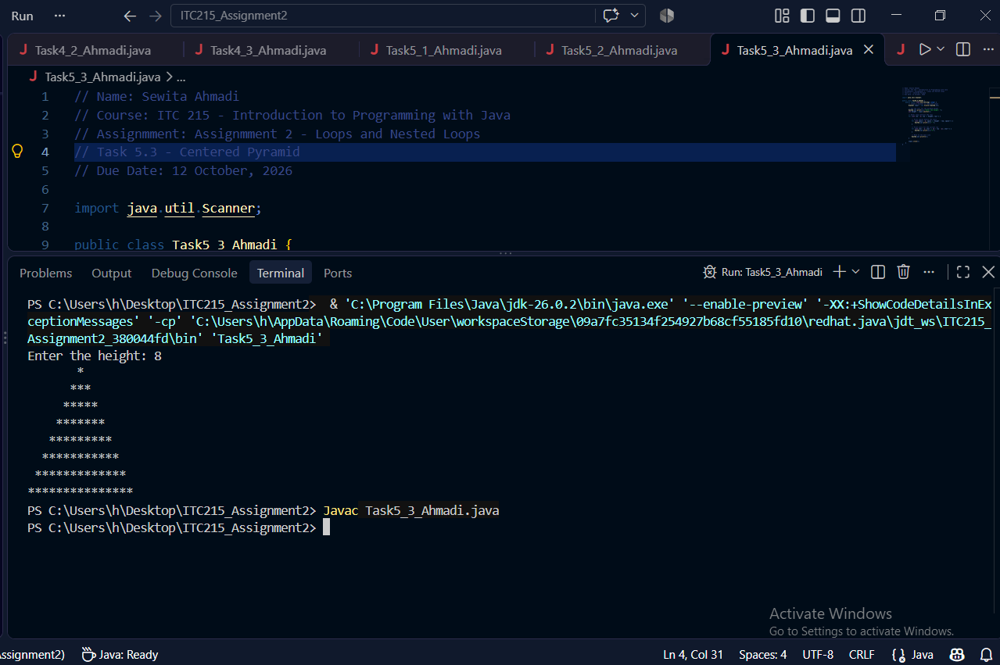
Task 5.4 Output screenshot
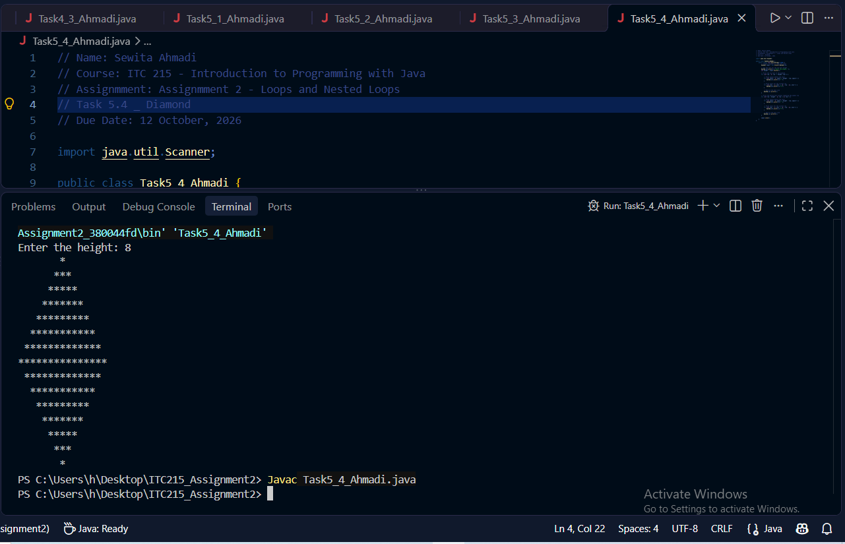
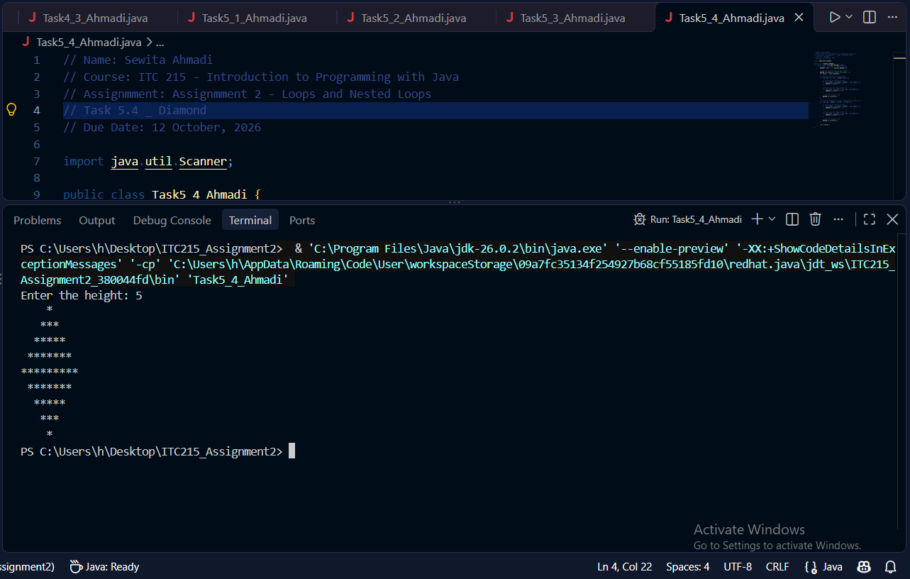

Part 6: Challanging Problems
Task 6.1 Output screenshots
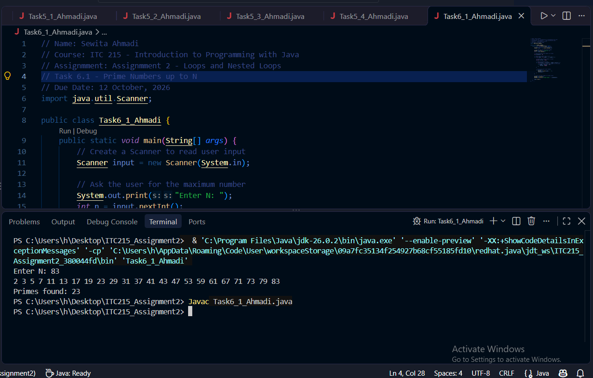
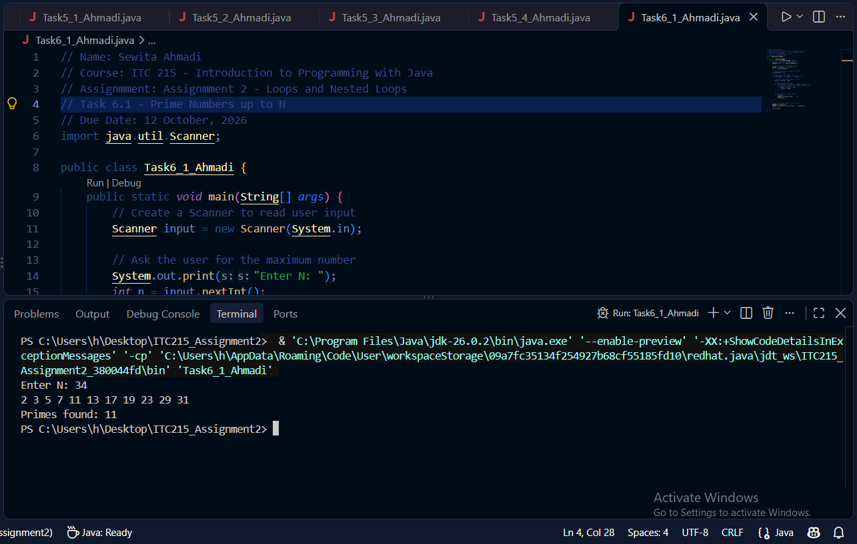
Task 6.2 Output Screenshot
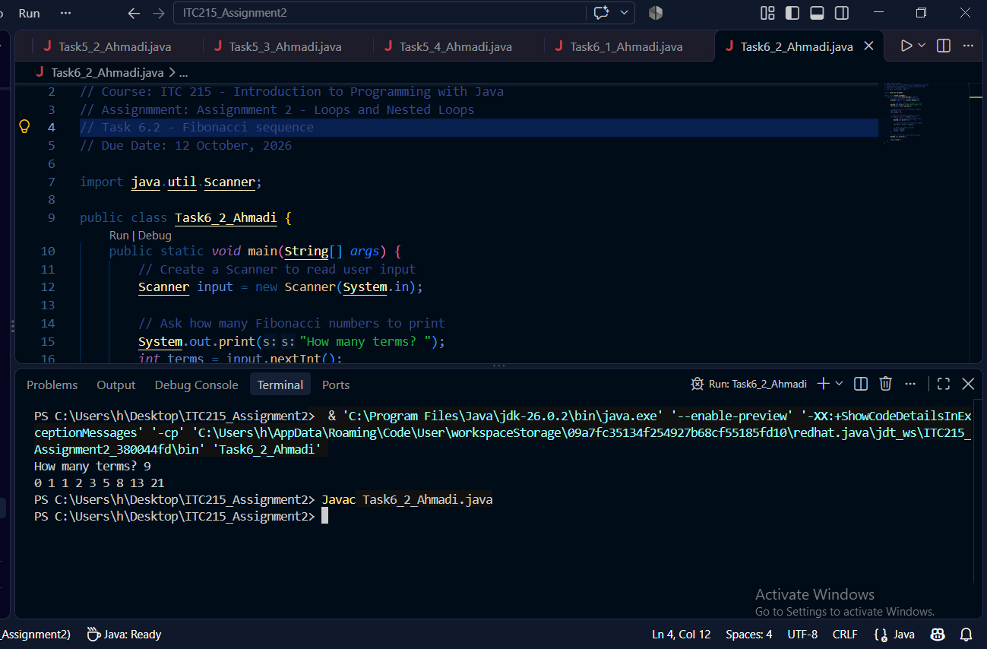
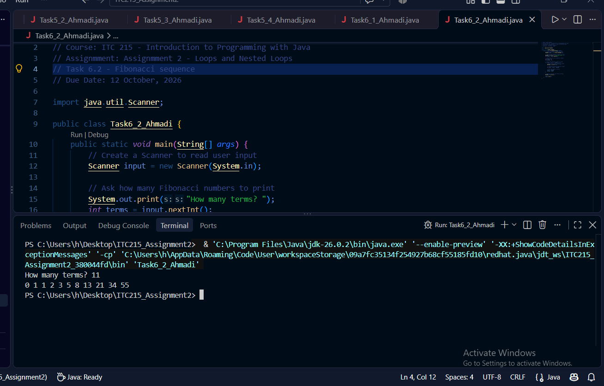

Task 6.3 Output Screenshot
